*//Q1. C program to swap two variables using pointers:*

*#include*<stdio.h>

void swap(int *x,int *y){

int temp;

temp = *x;

*x = *y;

*y = temp;

}

int main(){

int num1,num2;

printf("Enter num1:");

scanf("%d", &num1);

printf("Enter num2:");

scanf("%d", &num2);

printf("Before getting swapped: num1=%d, num2=%d\n", num1, num2);

swap(&num1,&num2);

printf("After getting swapped: num1=%d, num2=%d\n", num1, num2);

*return* 0;

}

**Output:**

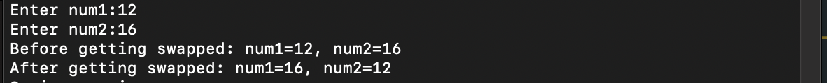

*//Q2. C program to read a text and count all occurances*

*// of a particular word.*

*#include*<stdio.h>

*#include*<string.h>

int main(){

int i=0,j=0,count = 0;

char str[100],copy[20];

printf("Enter a sentence:");

gets(str);

char word[20];

printf("Enter the word:");

gets(word);

*while*(str[i]!='\0'){

*while*(str[i]!=' '&&str[i]!='\0'){

copy[j]=str[i];

++j;

++i;

}

copy[j]='\0';

j=0;

*if*((strcmp(copy,word))==0){

count+=1;

}

*if*(str[i]=='\0')

*break*;

*else*

i++;

}

printf("The number of occurences of %s is %d", word, count);

*return* 0;

}

**Output:**



*//Q3. Write a C function to find the largest of three*

*//numbers using pass by reference.*

*//The function to find the largest should return a pointer.*

*#include*<stdio.h>

int *largest(int *a, int *b, int *c){

static int x;

x = (*a>*b? (*a>*c?*a:*c):(*b>*c?*b:*c));

*return* &x;

}

int main(){

int a,b,c;

printf("Enter 3 numbers:\n");

scanf("%d %d %d", &a, &b ,&c);

printf("The largest number is %d\n", *largest(&a,&b,&c));

*return* 0;

}

**Output:**



*//Q4. WACP using pointers to read in an array of*

*//integers and print its elements in reverse order.*

*#include*<stdio.h>

int main(){

int arr[100];

int n,i;

int *ptr;

printf("Enter the size of the array: ");

scanf("%d", &n);

ptr = arr;

printf("Enter the elements of the array: \n");

*for*(i=0; i<n; i++){

scanf("%d", ptr);

ptr++;

}

printf("Before reversing:\n");

ptr = arr;

*for*(i=0; i<n; i++){

printf("%d ", *ptr);

ptr++;

}

printf("\nAfter reversing:\n");

ptr = &arr[n-1];

*for*(i=0; i<n; i++){

printf("%d ", *ptr);

ptr--;

}

*return* 0;

}

**Output:**

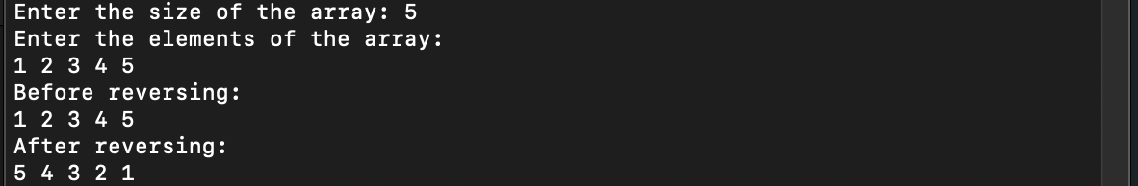

*//Q5. WACP to sort strings abc, deh, bac in*

*//ascending order using array of pointers.*

*#include*<stdio.h>

*#include*<stdlib.h>

*#include*<string.h>

int main(){

char *c[3];

int i, n=3;

void sort(int n, char *c[]);

*for*(i=0; i<n; i++){

printf("Enter string no. %d: ", i+1);

c[i] = (char *)malloc(3*sizeof(char));

scanf("%s", c[i]);

printf("\n");

}

sort(n,c);

printf("\nSorted strings are:\n");

*for*(i=0; i<n; i++){

printf("%d %s\n", i+1, c[i]);

}

*return* 0;

}

void sort(int n, char *c[]){

int i,j;

char t[20];

*for*(i=0; i<n-1; i++ ){

*for*(j=i+1; j<n; j++){

*if*(strcmp(c[i],c[j])>0){

strcpy(t,c[j]);

strcpy(c[j],c[i]);

strcpy(c[i],t);

}

}

}

*return*;

}

**Output:**

